PLC REPEATED NOTES FULL

**📌** DEFINITION OF A PLC (Programmable Logic Controller)

A Programmable Logic Controller (PLC) is a solid-state, specialized industrial computer built for **harsh** **environments**, **storing** and **executing** control instructions to manage machines or processes in real-time with extreme reliability, essentially acting as the rugged "brain" of industrial automation engineered for 24/7 operation.

**⚙️** TYPICAL INSTRUCTIONS STORED IN A PLC

When you write a PLC program, you’re basically feeding it a bunch of instructions. Here are the classics:

**🔄** Sequencing

Controlling the step-by-step progression of processes, much like following a TikTok recipe, is achieved through sequencing, often utilizing methods such as step coils, state machines, or sequential function charts.

**🛺** Timing

**Timers** (like ON-delay, OFF-delay, and retentive timers) are crucial for precisely controlling time-based actions and transitions in processes, allowing you to implement delays or specific durations, such as waiting a set number of seconds before opening a valve.

**🔢** Counting

Counters, including up-counters, down-counters, and combined counter-timer logic, precisely track events and control actions, such as counting products on a line and triggering an event when a specific number is reached, while also enabling batching and overflow management.

**➕** Arithmetic

Supporting both integer and floating-point operations, arithmetic functions allow for basic mathematical calculations on machine data, such as adding, subtracting, multiplying, or dividing numbers, which is essential for scaling sensor data, calculating setpoints, or implementing custom algorithms.

**📦** Data Manipulation

Bit-level and word-level operations, including masking, shifting, rotating, and BCD conversions, facilitate moving, comparing, or swapping numbers like playing cards, enabling complex signal conditioning or data packing and unpacking.

**🌐** Communication

**Industrial protocols** like Modbus, Profibus, and Ethernet/IP enable PLCs to "gossip" with each other, HMIs, or SCADA systems, thus coordinating with external devices, peer PLCs, or supervisory systems.

Typical Instructions in a PLC program:

* 🔄 **Sequencing** – step-by-step process control.
* 🕑 **Timing** – timers for delays and durations.
* 🔢 **Counting** – counting events, products, or cycles.
* ➕ **Arithmetic** – math on inputs, outputs, or variables.
* 📦 **Data Manipulation** – move, compare, or edit data.
* 🌐 **Communication** – talk to other devices and systems.

**📌** What Are PLCs Used For?

A PLC’s whole reason for existing is **to control and automate stuff in the real world** — especially in places too rough or complex for a normal computer.  
Here’s where you’ll see them flexing:

* ✅ Machine Control:  
  They’re the brain behind automated machines on factory floors — controlling motors, valves, and sensors with split‑second precision.
* ✅ Car Wash Systems:  
  Every step in an automatic car wash — soap, brushes, rinse, dryers — is sequenced by a PLC so your car gets clean without human intervention.
* ✅ Bottling & Packaging Lines:  
  PLCs handle the timing, counting, and coordination needed to fill bottles, cap them, label them, and pack them at insane speeds.
* ✅ Material Handling:  
  Conveyor belts, robotic arms, elevators, and palletizers all rely on PLCs to move products smoothly and safely through a plant.
* ✅ Data Acquisition:  
  PLCs don’t just control — they also **collect data** from sensors (temperatures, pressures, flow rates) and send it to HMIs, SCADA systems, or cloud dashboards.
* ✅ Pipeline Monitoring:  
  Oil, gas, and water pipelines use PLCs to watch pressures, control valves, and trigger alarms or shutdowns if something goes wrong.
* ✅ Hydroelectric Dams:  
  Gates, turbines, and safety interlocks are coordinated by PLCs to maintain power output and protect equipment.
* ✅ Process Control:  
  Industries like pharmaceuticals or refineries use PLCs to handle multi‑stage processes with loops, PID control, and precise logic.
* ✅ Food Mixing or Cooking:  
  In large-scale food plants, PLCs run mixers, heaters, and coolers to hit exact recipes, temperatures, and timings.
* ✅ Chemical Processing:  
  When handling chemicals, you need perfect timing, flow control, and safety shutdowns — PLCs are built for that level of reliability.

💡 Bottom line:

If it moves, mixes, counts, heats, cools, measures, or sequences — a PLC can control it.  
They’re everywhere in modern automation, silently running the show behind the scenes.

Typical PLC System Components

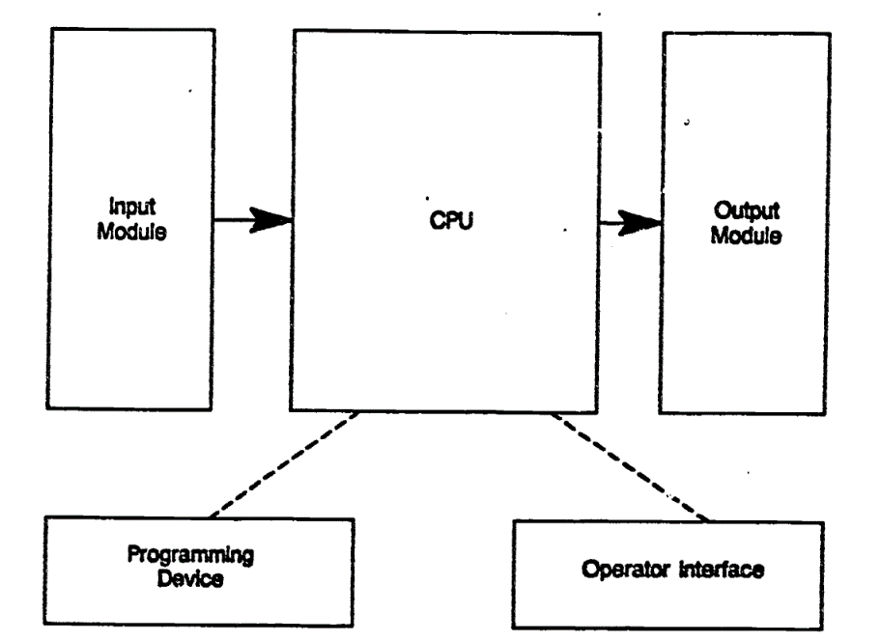

A PLC isn’t just a single magic box — it’s a **team of modules** working together:

✅ Input Module

* Brings signals from the field (sensors, switches, limit detectors).
* Converts those real‑world electrical signals into data the CPU can read.

✅ CPU (Central Processing Unit)

* The *brain* of the PLC.
* Reads input data, runs your program logic, makes decisions, and figures out what outputs should do.

✅ Output Module

* Takes decisions from the CPU and drives actuators (motors, solenoids, lights, valves) in the real world.
* Converts CPU signals into the correct power levels for field devices.

✅ Programming Device

* This is how *you* talk to the PLC.
* Used to create, download, and edit the logic (ladder diagrams, structured text, etc.).
* Think laptops, handheld programmers, or special config tools.

✅ Operator Interface (HMI – Human Machine Interface)

* The dashboard for operators.
* Shows process info (temperatures, states, alarms) and lets operators tweak parameters (like setting a new speed or temperature).

**✨** How it all flows (based on the diagram):

1. **Input Module ➡️ CPU:** Sensors send signals → CPU reads them.
2. **CPU does the logic:** Your program decides what should happen.
3. **CPU ➡️ Output Module:** Sends commands to field devices.
4. **Programming Device:** Engineers use it to load or change the logic.
5. **Operator Interface:** On the plant floor, operators monitor and adjust the system in real time.

💡 Big picture:  
A PLC is basically *eyes (inputs), a brain (CPU), hands (outputs)* — with engineers (programming device) teaching it, and operators (HMI) talking to it while it’s running.

TERMINAL

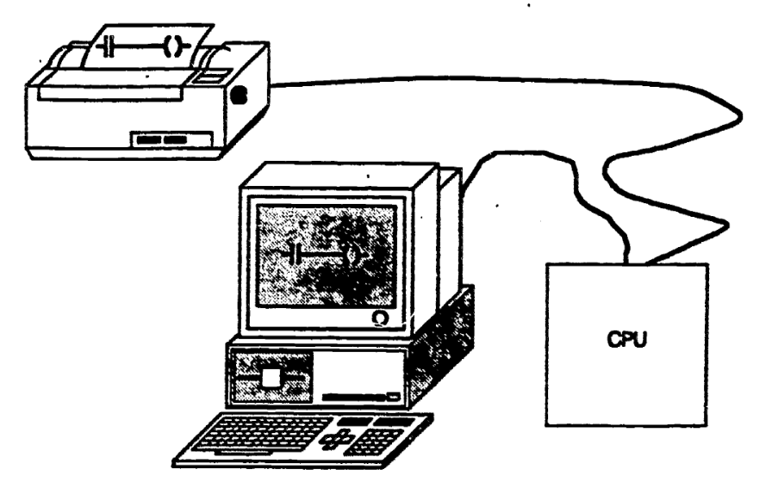

**📌** Terminals in PLC Systems

A **terminal** is a hardware device that acts as a **bridge between a human and a computer system** — basically, it’s how people interact with machines before modern graphical interfaces became common.

**🖥️** Types of Terminals:

* **CRT (Cathode Ray Tube Terminal)**
  + Old-school monitor + keyboard setup.
  + Used for fast, real-time interaction with the system (entering commands, viewing status, editing programs).
  + Think of it as the OG "command-line interface" workstation in industrial settings.
* **PRINTER Terminal**
  + Not for controlling — but for **documenting**.
  + Used to get a printed version of your PLC program, error logs, process reports, or configuration files.

**🧾** Hardcopy

* Means a **physical printout**, usually on paper.
* For backups, records, or sharing with other engineers.

**💡** Real Talk:

Before modern touchscreen HMIs and laptops, **terminals were the only way** to talk to your PLC. Today, they’re mostly legacy — but understanding them helps when working on older systems or reading historical documentation.

**📌** Discrete Inputs (a.k.a Digital Inputs)

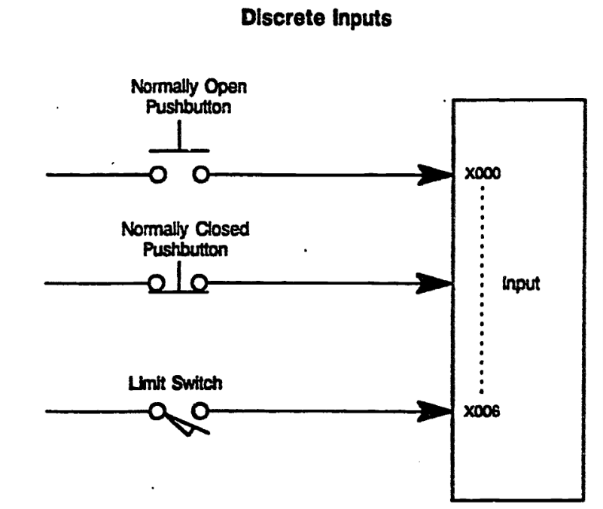

**💡** What is a Discrete Input?

A **discrete input** is a simple ON or OFF signal sent from a field device to the PLC.  
It’s **binary** — either HIGH (1) or LOW (0), no in-between.

**🧠** Examples of Discrete Input Devices:

These devices act like *switches* — either giving power or not:

* 🟢 **Pushbuttons** (Normally Open / Normally Closed)
* ⚙️ **Limit switches** (detect positions of machine parts)
* 💧 **Float switches** (detect fluid levels)
* 🔄 **Toggle switches**
* 📈 **Flow switches / pressure switches**
* 🦶 **Foot pedals / safety interlocks**
* 🧲 **Proximity switches** (detect presence of objects without contact)

**🔌** Wiring & Addressing: I/O Points

* **I/O points** are the terminals where field devices physically connect to the PLC input modules.
* Each input is mapped to a specific address in the PLC's memory.  
  For example:

X000 = 1st discrete input  
X006 = 7th discrete input

* This address can be auto-assigned or manually configured based on your PLC type and software.

**✍️** Diagram Breakdown:

Let’s decode the diagram you shared:

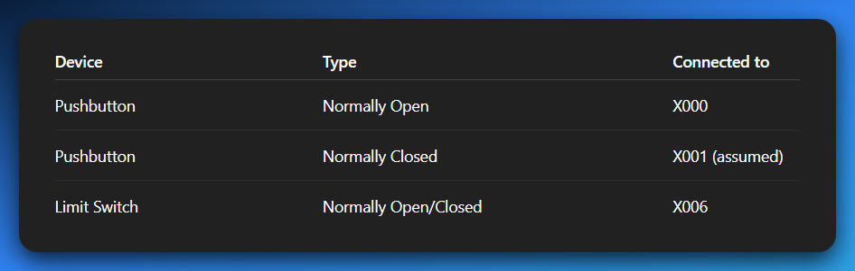

Each arrow represents a **signal wire** going into an **input point** on the PLC module. When the device is activated, the corresponding input bit (like X000) flips from **0 → 1** or **1 → 0** depending on the wiring logic.

**🧠** Nick’s Mental Model:

Think of discrete inputs as **the PLC’s ears** — they tell it,  
*“Hey! This button was pressed.”  
“That valve reached its end.”  
“A box just passed the sensor.”*And the CPU listens and acts based on your program logic.

ANALOG INPUT

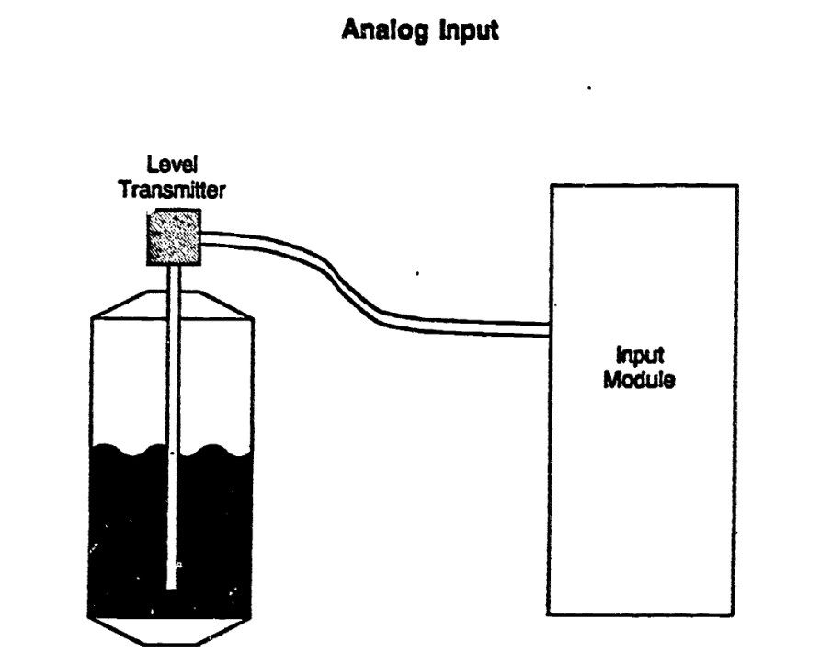

**📌** Discrete Outputs (Digital Outputs)

Just like inputs tell the PLC what’s happening outside, **discrete outputs** are how the PLC **tells machines what to do.**

A **discrete output** sends an ON or OFF signal to a field device — nothing fancy, just pure binary power delivery.

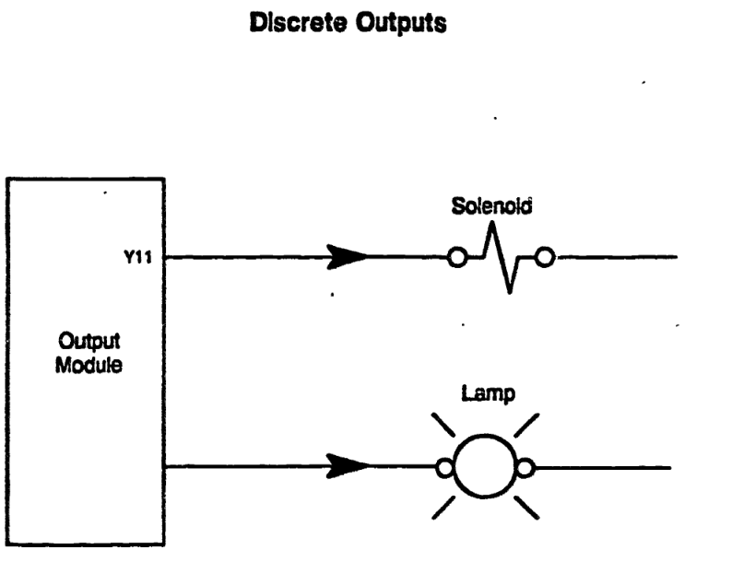

**⚡** What Are Discrete Outputs Used For?

They control devices that either:

* turn ON/OFF
* open/close
* light up or go dark

**🔧** Common Examples:

* **Solenoids** – to open/close fluid or air valves
* **Contactor Coils** – for switching high-power circuits
* **Indicator Lamps / Pilot Lights** – to show machine status
* **Buzzers / Alarms** – to signal errors or events
* **Small Motors or Relays** – in basic control setups

**🧰** Wiring & Addressing:

Just like inputs, outputs are also connected to specific terminal points on the **output module**.

Each output gets a **unique address**, e.g.:

*Y011 = 12th discrete output (starting from Y000)*

These addresses can be set automatically or manually during setup/configuration.

**🧠** Nick’s Mental Model:

If **discrete inputs are the PLC’s ears**,  
then **discrete outputs are its hands.**  
The CPU listens to what's happening → runs the logic → and then uses outputs to take action.

**Example:**

If X000 (button press) is ON, then Y011 (lamp) turns ON.

That’s classic **input → logic → output** flow.

Analog Outputs

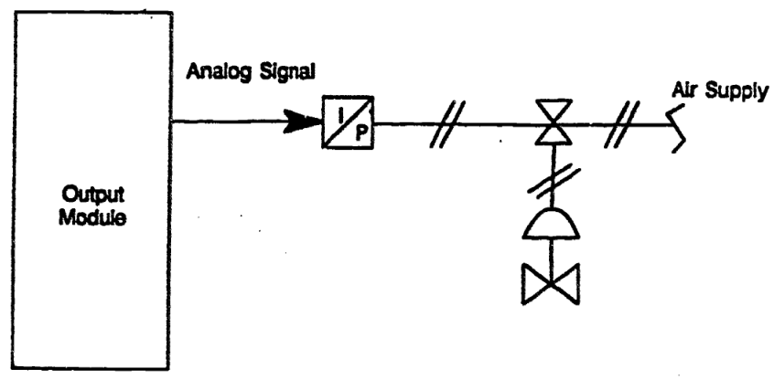

**Analog Output** refers to an electrical signal sent *from* the PLC *to* an external field device, where the value of the signal is continuously variable, not just ON or OFF. These outputs are typically used to control devices that need **precise, adjustable control**, rather than just binary states.

**🌀** What Is an Analog Signal?

An **analog signal** is a continuously variable signal. It can represent a whole range of values — for example, anything from **0 to 10 volts**, or **4 to 20 milliamps** (mA). This is different from digital/discrete signals which are either **on (1)** or **off (0)**.

Think of it like a dimmer switch on a light — not just ON/OFF, but gradually increasing brightness. That’s what analog signals do: provide a smooth range of control.

**📥** How Analog Outputs Are Used

They’re mainly used for **fine control** of physical devices that require variable levels of operation. Here are key examples:

* **Motor speed controllers** – to control the RPM of a motor smoothly
* **Flow control valves** – to let more or less fluid through
* **Temperature regulation systems** – for variable heating or cooling
* **Positioning systems** – like for a robotic arm that needs gradual, smooth movement

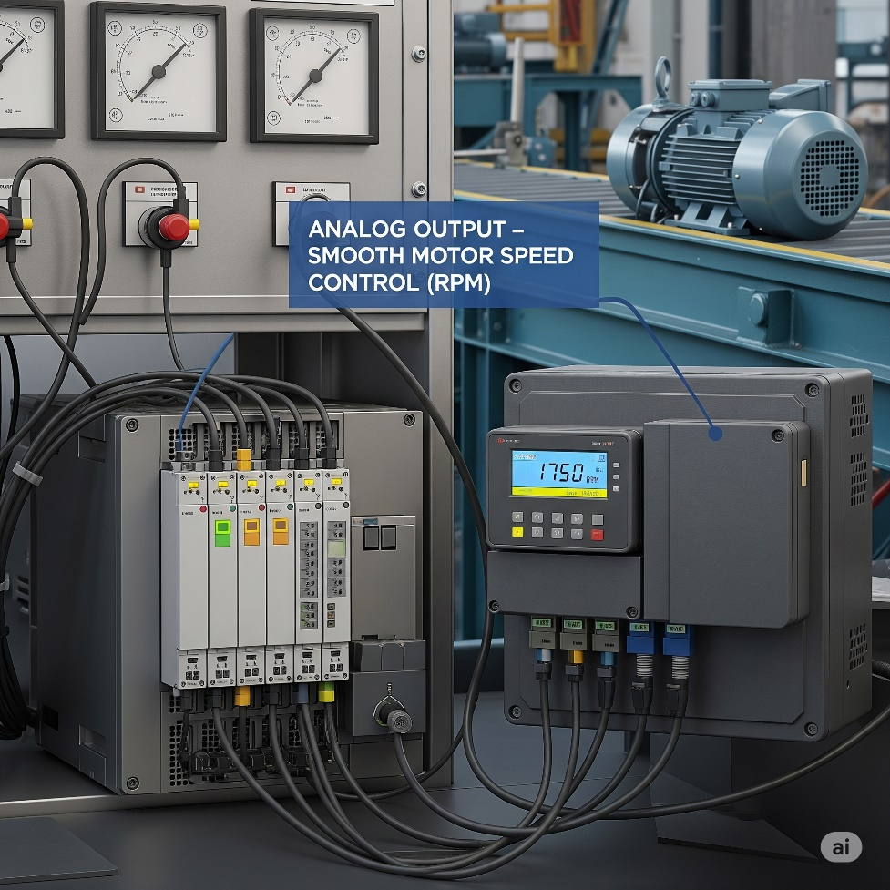

**🛠️** Real-World Example:

Current-to-Pneumatic Transducer (I/P Transducer):  
The PLC sends a **4–20 mA** current signal to the transducer. The transducer converts this electrical signal into a proportional **air pressure** that adjusts a **pneumatic valve** in a flow-control system.

* If the PLC outputs **4 mA**, the valve may open only slightly.
* If the PLC outputs **20 mA**, the valve may fully open.
* Anything in between gives **partial openings**, allowing **precise control of flow**.

**🧠** Extra Details to Keep in Mind:

* The **proportionality** of analog output depends on the whole control loop:
  + The **primary element** (sensor or input device)
  + The **transmitter** (converts sensor data to electrical signal)
  + The **controller (PLC)** and its output scaling
  + The **actuator** or device receiving the analog signal
* Sometimes, due to mechanical or electrical factors, the system might behave in a **non-linear (disproportionate)** way — meaning that doubling the signal doesn't necessarily double the effect.

**🧾** Summary (Quick Bites):

* **Analog output = variable signal from PLC (e.g., 4-20mA or 0-10V)**
* Used for **precise control** over devices like valves and motors
* Enables **gradual change**, not just ON/OFF
* Real-life use: controlling a valve in a water plant, adjusting motor speed in a conveyor system, etc.

**🧠** Central Processing Unit (CPU) — The PLC’s Brain

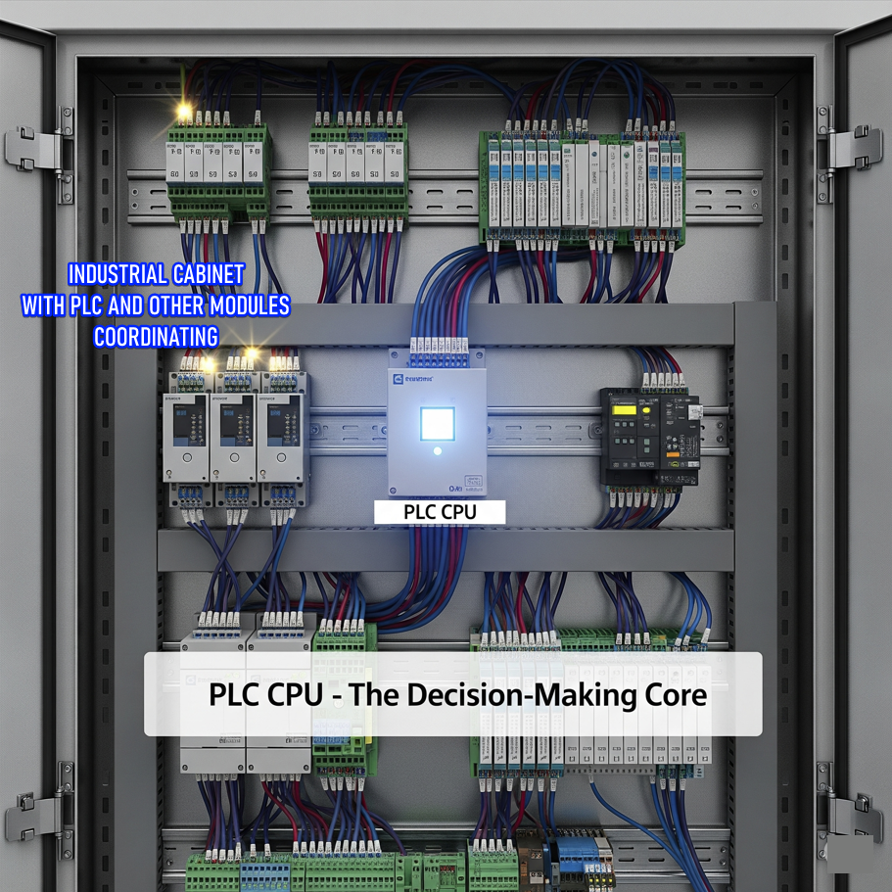

The **CPU** is the heart of the PLC. It's the boss that runs the show. It handles **decision-making** and manages **user memory**, both of which are **fully controlled by the programmer i.e. you 😈).**

The CPU has two main responsibilities:

**🧩** 1. Decision-Making Section

This is the logic engine. It's where all the **“if this, then that”** type of rules are executed.

**✅ What does it do?**

* It reads signals coming in from the field (sensors, switches, etc.)
* It **compares those inputs against your programmed instructions**
* Based on that, it decides what outputs to activate or deactivate

**⚙️ Example:**

***“If the water tank is full, then turn off the inlet valve.”***

This logic is written in your program using conditions. The CPU constantly checks input values (like a float switch in the tank) and executes this rule if the condition is true.

So really, it's like a 24/7 vigilant robot, constantly scanning inputs, and flipping outputs based on your custom logic.

**🗃️** 2. User Memory Section

This is where your program and working data live.

**🧠 What’s stored here?**

*Instructions (Your actual program — logic, sequences, etc.)*

*Application-specific data, like:*

* Current status of inputs and outputs
* Temporary storage for values (like timers, counters, internal flags)
* Recipes, setpoints, operator-entered data

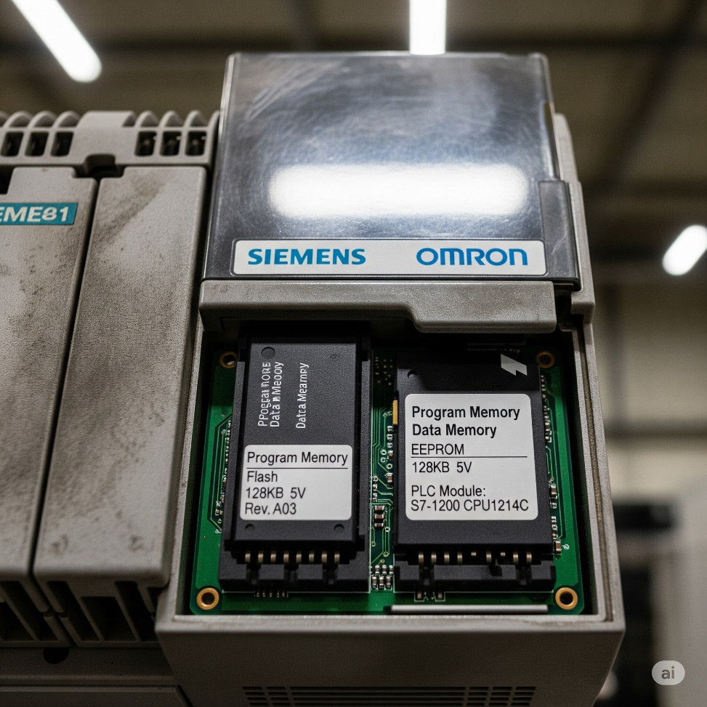

**📝** Real Talk:

If the CPU is the brain, then the **user memory** is like a combo of short-term memory (RAM) and long-term habits (program logic). Your logic tells it what to do, and the CPU keeps checking reality to follow those instructions.

**🧪** Summary with Example Flow

1. Input says: “Tank is full” → sensed by a float sensor.
2. CPU reads this input.
3. It checks your program (user memory): IF tank is full THEN close valve.
4. Decision is made: Close the valve.
5. Output is activated to shut off the valve via a relay/solenoid.

That’s how **industrial automation magic** happens. Simple, logical, powerful.

**🧠** Central Processing Unit (CPU) — The Brain of the PLC part 2

**🗯** Simple Explanation (Teen Mode)

The CPU in a PLC is like the brain of the system. It:

* **Thinks (Decision-Making):** Like deciding, “Hey, the tank is full — I better turn off the water valve.”
* **Remembers (User Memory):** It holds two things:
  1. ***The “how-to” list (instructions you give it).***
  2. ***The “what's happening” info (current readings or values from sensors).***

The CPU does *exactly* what it’s told. If the instructions are dumb, it’ll do dumb stuff — just *very* fast and *very* accurately. It doesn’t ask questions. It just obeys.

**🛠️** Software, Hardware, Firmware — Let’s Demystify This

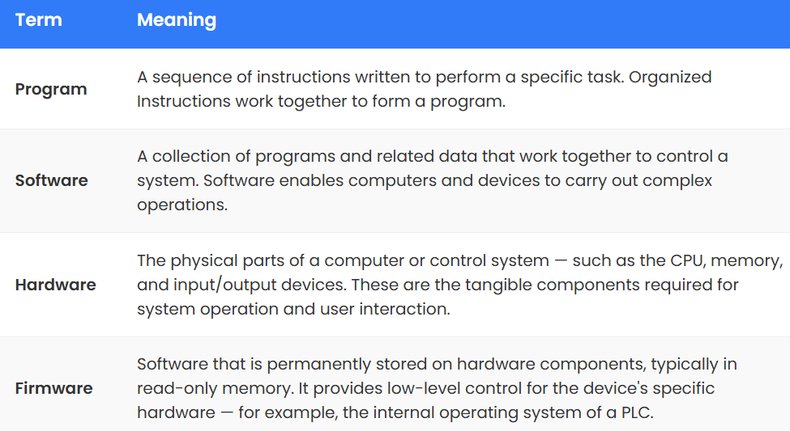

🔁 The CPU runs two “layers” of code:

* **Firmware**: Low-level code (like an OS) that makes the PLC even *function*. You can't edit this — it’s stored inside the chip.
* **User Software**: Your custom ladder logic or structured text. This is the code that makes your specific plant or machine behave how you want it to.

Just like a PC:

* **Windows 10** = PLC firmware
* **Chrome** = Your PLC program

**💡** Languages the PLC Understands

1. **Relay Ladder Logic (RLL):**
   * Graphical.
   * Inspired by old-school relay schematics.
   * Most beginner-friendly.
   * Looks like electrical diagrams = makes sense to electricians.
2. **Machine Stage Programming:**
   * Think: ladder logic + sequential flowchart.
   * Perfect for machines with stages (like washing machines, bottling lines, etc.).

**🔥** Wrap-Up Quote:

The CPU is not *smart*. It’s *fast*. It's not creative — it's obedient. Give it bad logic, and it’ll mess things up with **machine-level precision**.

🧠 PROGRAMMING A PLC: THE BIG PICTURE

When you hear “PLC Programming,” you're basically talking about telling a small industrial computer (the CPU of the PLC) **what to do and when to do it**. But that involves several components working together:

**🔧** 1.HARDWARE

This is the **physical stuff** — the actual PLC box, the input/output modules, the wiring, power supply, etc.

* **Examples**:
  + CPU (Central Processing Unit)
  + Input/Output modules (for sensors, actuators)
  + Power supply
  + Communication ports
  + Mounting base or chassis

**💽** 2.FIRMWARE

This is the **built-in software** inside the PLC hardware — like its operating system.  
It controls basic operations (scan cycle, timing, comms, etc.) and lives inside a chip.

* **Think of it like this**:
  + **Firmware = Windows for your PLC**, but you can't uninstall or modify it.
  + It's burned into the memory of the PLC (ROM or flash).

**📄** 3.SOFTWARE

This is **your program** — the logic the PLC will execute based on the conditions it reads.  
It’s created by you (the programmer), uploaded into the PLC, and stored in its **user memory**.

* **User memory** stores:
  1. The actual instructions (the program).
  2. Process-dependent info (e.g., sensor values, counters, flags).

**💻** 4.PROGRAMMING TOOLS

You need a device to **write, upload, and monitor** your programs. These are usually:

* **PCs** (modern choice)
* **Handheld programmers** (old-school, niche but still in use)

**⚙️ 5.** PROGRAMMING MODES

There are two ways to interact with your PLC during programming:

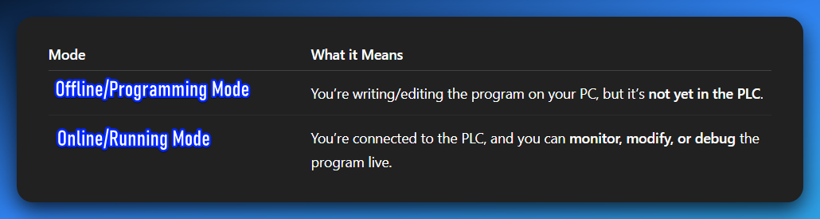

***Offline Mode -***This mode is where you do all your initial development, major overhauls, or bug fixes without affecting the live process. It's like working in a sandbox. Changes only exist on your computer. The PLC itself is either running an old program, or if it's new, it has no program at all.

***Online Mode* -** Where you can make small changes to the program without stopping the PLC. This is usually for minor tweaks, debugging or bug fixes. For bigger changes, you'd typically go offline. It's like adjusting your car's mirrors while driving – small, immediate changes.

**💬** 6. PROGRAMMING LANGUAGES

You can't just write English and expect the PLC to understand. It needs **languages it understands**:

a) Relay Ladder Logic (RLL)

* Most common.
* Looks like electrical relay schematics.
* Visual and great for electricians and techs.
* Uses contacts, coils, timers, counters, etc.

b) Boolean Logic

* The math behind all digital logic:
  + AND, OR, NOT, NAND, NOR
  + Often represented graphically in RLL

c) Computer-like Languages (Text-Based)

Some PLCs support structured text, instruction lists, or even Python-like languages. This depends on the brand (Siemens, Mitsubishi, Allen-Bradley, etc.).

**🔥** Bonus Insight: Double Execution in the CPU?

You're **spot on** with this analogy:

**“The CPU handles double work — system stuff (like starting itself) and user programs (PLC code).”**

Yes, the **firmware handles the PLC’s own health and system tasks**, while the **user program runs your logic for controlling the machines**. They coexist but don’t step on each other.

* **Hardware** = physical components
* **Firmware** = pre-installed OS of the PLC
* **Software** = the program you write
* **Programming devices** = PC or handheld (images in the other book)
* **Modes** = Off-line (write), On-line (monitor/test)
* **Languages** = Ladder Logic (visual), Boolean (logic base), or text-based (advanced)

RELAY LADDER DIAGRAM

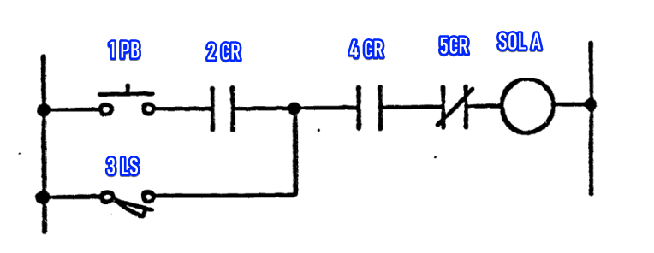

Based on the relay ladder diagram, here's a short description of its components and operation:

This diagram represents a control circuit using rungs and rails, common in industrial automation. There are six distinct components involved in controlling a solenoid.

The six components are:

1. **1PB (Push Button):** This is a normally open (NO) push button. When pressed, it allows current to flow.
2. **2CR (Control Relay 2):** This is a normally open (NO) contact from control relay 2. It closes when control relay 2 is energized.
3. **3LS (Limit Switch):** This is a normally open (NO) limit switch. When actuated, it allows current to flow, providing an alternative path to the 1PB.
4. **4CR (Control Relay 4):** This is a normally open (NO) contact from control relay 4. It closes when control relay 4 is energized.
5. **5CR (Control Relay 5):** This is a normally closed (NC) contact from control relay 5. It opens when control relay 5 is energized, interrupting the circuit.
6. **SOL A (Solenoid A):** This is the output device, a solenoid, which is activated when current flows through it.

In operation, Solenoid A will energize if either the 1PB is pressed AND 2CR is closed, OR if the 3LS is actuated.

Additionally, for the solenoid to energize, 4CR must be closed AND 5CR must NOT be energized (meaning its normally closed contact remains closed).

Essentially, it's a logic circuit where multiple conditions must be met in sequence or parallel for the solenoid to activate.

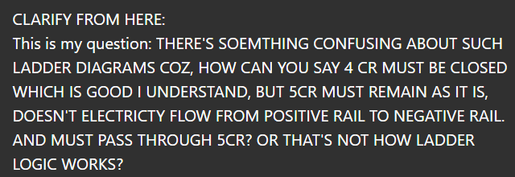

**🧠** First: YES — Electricity flows left to right in a ladder diagram.

* Just like a book, ladder diagrams are read from **top to bottom** and **left to right**.
* The **left vertical rail = L (Live)**
* The **right vertical rail = N (Neutral)**
* Current flows **from L to N** through the rungs — same way logic flows.

**🧩** Now: Let’s decode the mystery around 5CR

You're 100% right to question:

*“Doesn’t the current still have to go through 5CR? So how can you say '5CR must not be energized'?”*

This is where **ladder logic’s secret sauce** kicks in — the concept of **contacts being “controlled” by other relays or coils**.

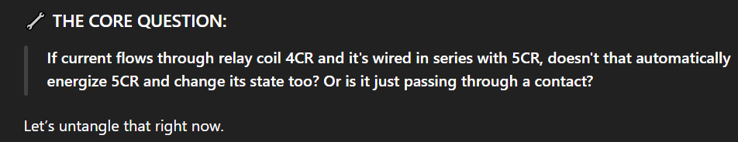

We gotta separate two things cleanly:

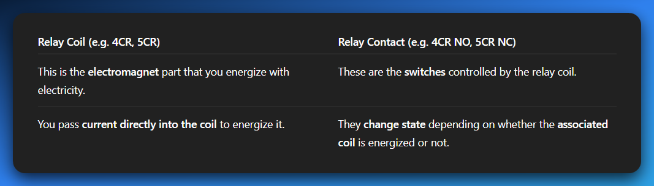

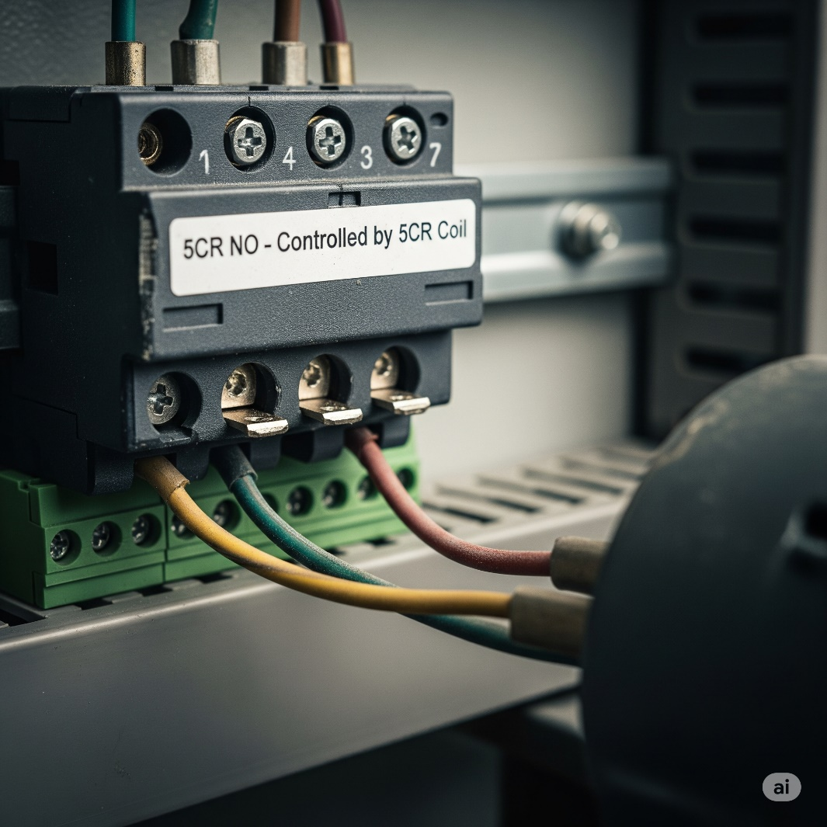

Let’s expand on that a little bit more…

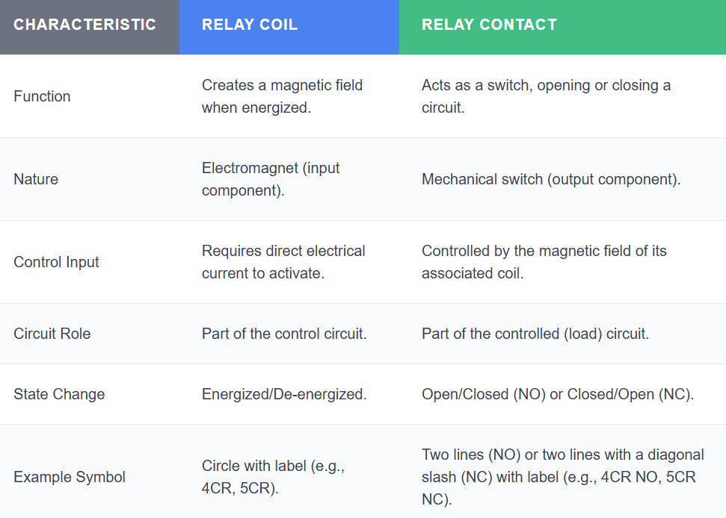

**👇 Back to Your Circuit:**

Let’s say you have:

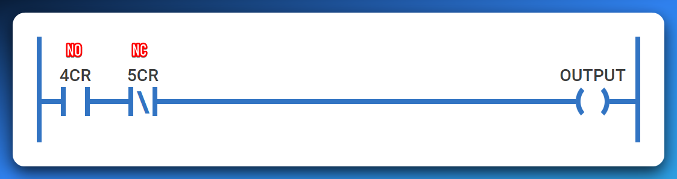

Here’s what matters:

4CR and 5CR are not actual wires or power routes.

They're **contacts** controlled by relays **somewhere else**.

You’re not "passing electricity **through** a relay coil." You're passing electricity through **relay contacts**.

🔄 So when you close the 4CR relay, it energizes its **own coil**, and **its own contacts change** wherever they are.

✋ But if there's a **5CR NC contact** in that rung, whether it allows current or not **depends on the state of 5CR's coil**, **not** on the current coming from 4CR.

In short:

* **You’re not passing current into 5CR coil here.**
* You’re passing through the **contact** controlled by 5CR.
* So, if 5CR is energized **somewhere else**, its NC contact becomes **open**, breaking the circuit.

**✅** The Key Takeaway:

*Current doesn’t change a contact's state just by “passing through it.”*

A contact changes state **only when its matching coil is energized**.

If you're going through a 5CR contact, its state depends only on whether **5CR’s coil** is energized.

**🔄 So your thought:**

*“Since it must pass through 5CR, doesn’t it automatically open?”*

❌ **Nope.** It opens only if the 5CR relay coil is energized. Otherwise, it stays in its default state (normally closed or normally open).

**💡** Analogy (Gen Z mode):

Think of it like **smart home lights**.

* 4CR is a smart bulb. You control it with your phone (energize the coil), and it lights up (closes the contact).
* 5CR is another smart bulb, but its switch is somewhere else.
* Just because you're sending power to bulb A doesn't mean bulb B will react — unless **its own switch (coil)** is triggered.

**👀** Bonus: Physical vs Ladder Logic

In real-world relays:

* **The contact is just a mechanical switch** inside a relay block. No power goes *through* a relay coil by just touching a contact.
* You energize a coil -> internal switch flips -> your circuit reacts.

**✍️** Bottom Line:

🔌 Electricity **through a contact** ≠ electricity **through a relay coil**

🧠 Contacts change state only if their **relay coil is energized**.

So, your 4CR energizing doesn’t affect 5CR unless there’s a link somewhere in the logic to **energize 5CR’s coil**.

**💡** The BIG mistake students and teachers make:

**🔌** There are two things going on with a relay:

1. **The coil** (e.g., 4CR or 5CR coil) – when energized, **it changes the state** of that relay’s contacts.
2. **The contacts** (NO or NC) – are just **switches** that open or close **based on whether the coil is energized**.

Mistake? Thinking **current “passing through” a contact** changes its state.

**FALSE.** The contact's state **is not changed** by current *passing through* it — its state is only changed if the **coil** tied to it is energized.

**🧠** Example Walkthrough:

Let’s say we have:

* 4CR coil (controlled by some condition)
* 5CR contact (let’s say it’s a Normally Closed [NC] contact)

And 4CR's current is flowing **through** that 5CR contact. Here's what matters:

* If **5CR coil** is **not energized**, the contact **stays NC** → current flows normally.
* If **5CR coil** **is energized**, then and only then does its contact **open** → breaking the path.

➡️ The relay **contact is just a puppet.**  
➡️ The relay **coil is the puppeteer.**

**🔁** Don't Mix Up These Two:

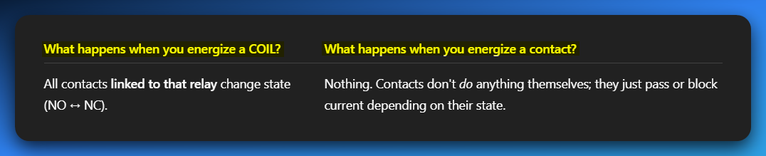

**🔧** Final Nail:

If current goes through a contact — **that does not change the contact.**  
The only thing that **changes a contact’s state** is **the COIL of that same relay being energized**.

**💬** You Said:

*“Doesn’t current already pass through 5CR so it becomes open contact?”*

**NOPE.**  
That’s where it tripped you up. The 5CR contact will only become open if the **5CR coil** is energized — not because current passed through it.

**🎯** Burn this in your memory:

**“Coil controls the contact. Contact does not control the coil.”**

FREE FORMAT EQUIVALENT PC DIAGRAM FOR THE SAME IMAGE DISCUSSED?

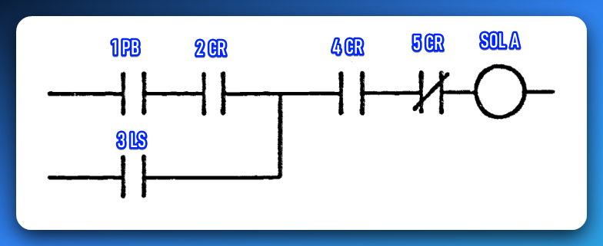

BOOLEAN STATEMENT?

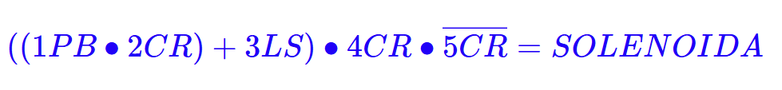

CODE OR MNEMONIC LANGUAGE?

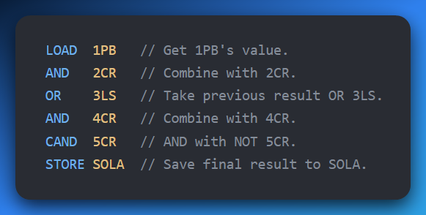

🔧 PLC Programming Languages — Comparison Table

**Ladder Logic (LD)** is the most commonly used language in PLCs, especially in standard industrial applications. It resembles electrical relay diagrams, which makes it intuitive for electricians to understand and troubleshoot.



**Function Block Diagram (FBD)** is often used in automation-heavy systems. It allows users to drag and drop logic blocks, making it especially appealing to visual thinkers who prefer graphical representations of control logic.

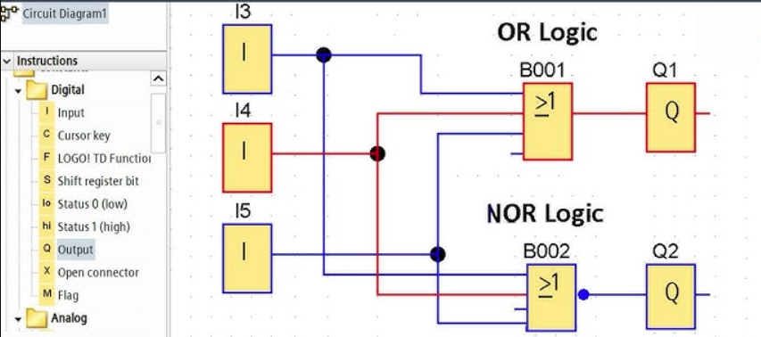

**Structured Text (ST)** is typically used in advanced control systems. It resembles the Pascal programming language and is best suited for applications involving complex logic or mathematical operations.

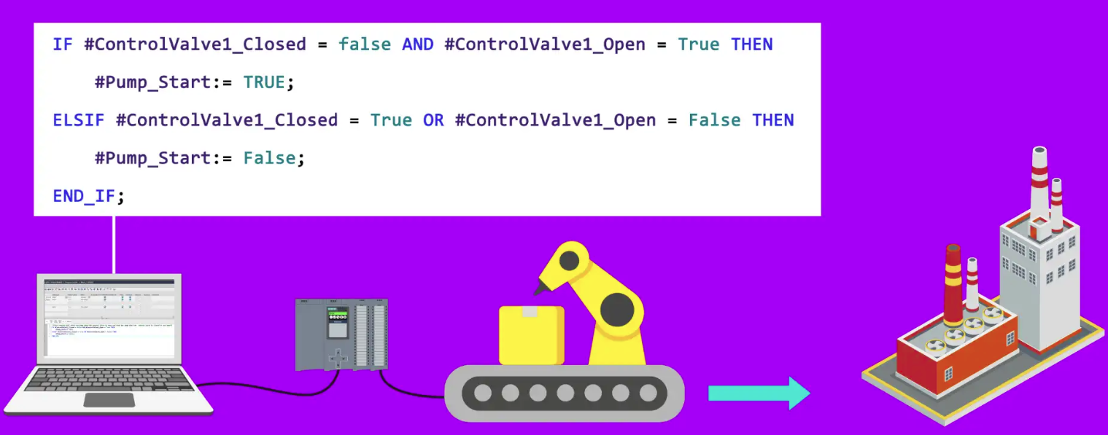

**Instruction List (IL)** is largely obsolete in modern PLCs. It is a low-level language that resembles assembly code. While deprecated, it may still be encountered in older systems.

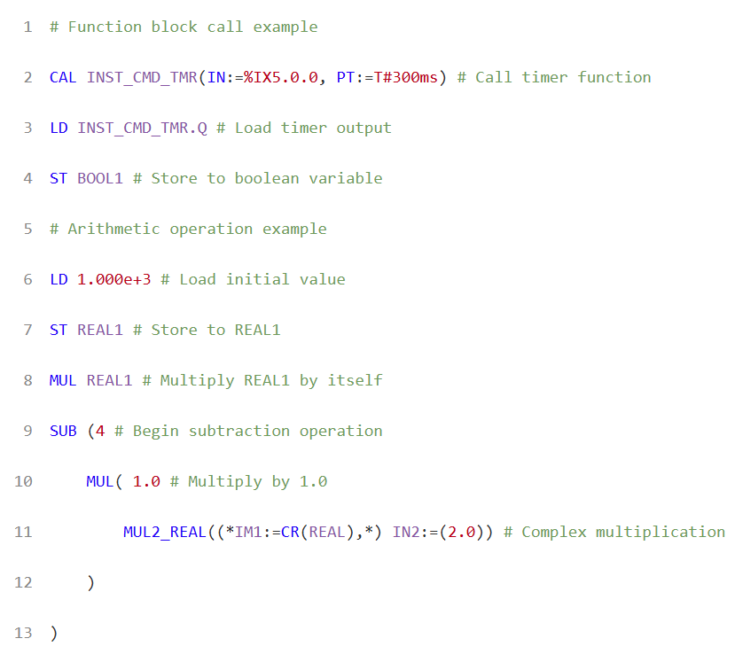

**Sequential Function Chart (SFC)** is ideal for batch processes. It is designed to represent step-by-step workflows using a visual state machine approach, making it excellent for modeling sequential operations.

